Building a Machine Learning System: Analyzing Bias and Variance for Improvement
Imagine you have a brilliant idea for a machine learning system...
( Light bulb moment!)
But then reality hits...
( Performance isn't quite there)
Don't worry, this is normal! Most ML systems require iterative improvement. Here's where bias and variance come in:
Think of bias as a stubborn friend:
(‍ Underestimates the problem)
- It leads to under fitting: The model doesn't capture the true complexity, like a student who memorizes facts but doesn't understand the concept.
Think of variance as an overenthusiastic friend:
( Over fits to irrelevant details)
- It leads to over fitting: The model learns the training data too well, including noise, like a student who memorizes specific exam questions instead of general principles.
So, how do we get these friends to work together?
Analyze their behavior:
- High bias: The model consistently under performs.
  - Solution: Increase complexity (more features, layers), collect more data, use less strict restrictions.
  - Illustration: Imagine predicting house prices. High bias might miss crucial factors like school district quality.
- High variance: The model's predictions are unpredictable, even for similar data.
  - Solution: Reduce complexity, apply regularization, use dropout (in neural networks), collect more diverse data.
  - Illustration: Imagine predicting customer churn. High variance might lead to wildly different predictions for similar customers due to over fitting to noise in the data.
Remember:
- It's an iterative process!
- Use visualization tools (learning curves, decision boundaries).
- Consider your domain knowledge.
By understanding bias and variance, you can make informed decisions to improve your ML system's performance, just like guiding your friends to work together for a better outcome!

Diagnosing Bias and Variance: Training vs. Validation Performance
Visualizing the Impact of Feature Dimensionality:
Remember the linear regression example?
- Straight line (d=1) had high bias, underfitting both training and validation data.
- 4th-degree polynomial (d=4) had high variance, fitting training data well but failing on unseen data.
- Quadratic polynomial (d=2) balanced the two, performing well on both training and validation data.
But what if we have more features (d > 1)? Plotting the function becomes difficult.
Here's a systematic approach:
- Analyze training and validation performance:
  - High J_train and J_cv: Indicates high bias (underfitting).
  - Low J_train but high J_cv: Indicates high variance (overfitting).
  - Low J_train and J_cv: Suggests good balance, like the quadratic model in our example.
- Visualize performance vs. model complexity (d):
- Plot J_train and J_cv as functions of the model's complexity (e.g., polynomial degree).
- High variance models will show a larger gap between J_train and J_cv.
Key Points:
- Analyzing J_train and J_cv is a powerful tool for diagnosing bias and variance, even without visualizing the function.
- High J_train suggests underfitting, while a large gap between J_train and J_cv points to overfitting.
- By choosing the model that balances J_train and J_cv, you can achieve optimal performance on both training and unseen data.
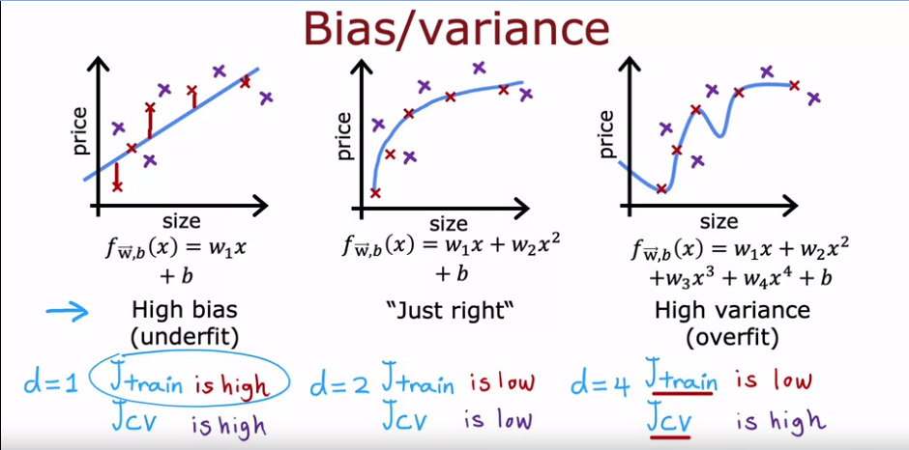

Visualizing Bias and Variance: J_train vs. J_cv and Model Complexity
Great suggestion! Here's an improved figure based on your description:
Horizontal Axis: Degree of polynomial (d)
Vertical Axis: Error (J_train and J_cv)
Curves:
- J_train: Starts high at low d (underfitting), gradually decreases with increasing d, and might slightly increase again at very high d due to overfitting.
- J_cv: Starts high at low d (underfitting), stays high or increases further at high d (overfitting), and has a minimum point somewhere in between, indicating the optimal model complexity.
Key Points:
- The minimum point of J_cv represents the sweet spot between bias and variance for the given data.
- J_train generally decreases with increasing complexity, while J_cv initially decreases but rises after overfitting takes hold.
- Comparing these curves helps identify the model complexity (d) that balances training and validation performance, avoiding high bias or variance.
Additional Notes:
- The specific shapes of the curves might vary depending on the data and model type.
- Regularization techniques can help prevent the J_train curve from dropping too low and the J_cv curve from rising too much at high d.
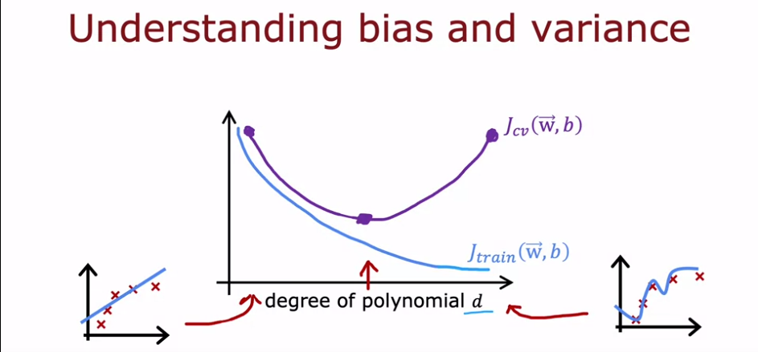

Diagnosing Bias and Variance: Key Points
High Bias (Underfitting):
- J_train: High (model doesn't fit training data well)
- J_cv: Usually close to J_train (both high)
- Example: Straight line fitting a curved dataset
High Variance (Overfitting):
- J_train: Low (model fits training data very well)
- J_cv: Much greater than J_train (model doesn't generalize well)
- Example: High-order polynomial fitting a small dataset
Simultaneous High Bias and High Variance:
- Less common in linear models with one feature
- Possible in neural networks
- J_train: High
- J_cv: Even higher than J_train
- Example: Overfitting part of the data while underfitting another part
General Tips:
- Analyze J_train and J_cv to diagnose bias and variance.
- High J_train suggests underfitting; large J_cv gap suggests overfitting.
- Both at the same time is possible but less common.
- J_train and J_cv curves help visualize the optimal model complexity.
Remember:
- Understanding bias and variance is crucial for improving machine learning performance.
- Analyze these factors to choose appropriate strategies for improvement.
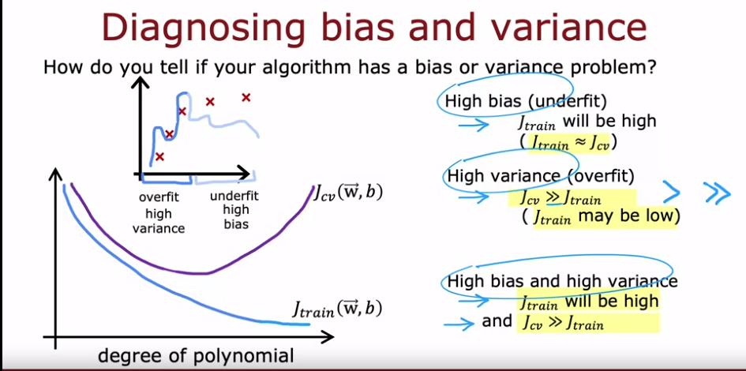

Regularization and Bias-Variance Trade-off: Choosing the Right Lambda
Let's explore how regularization (specifically the Lambda parameter) impacts bias, variance, and overall performance in machine learning.
Example: Fourth-Order Polynomial with Regularization:
- We'll use a fourth-order polynomial but apply regularization with different Lambda values.
- Lambda controls the trade-off between keeping parameters small (avoiding overfitting) and fitting the training data well (avoiding underfitting).
High Lambda (e.g., 10,000):
- Parameters (w_1, w_2, ...) become very small.
- Resulting model is roughly a constant line, indicating high bias (underfitting).
- J_train is large (poor fit on training data).
Low Lambda (e.g., 0):
- No regularization, equivalent to a normal fourth-order polynomial.
- Overfits the training data, leading to high variance.
- J_train is small (good fit on training data), but J_cv is much larger (poor generalization).
Optimal Lambda:
- Aims for a model that balances J_train and J_cv, avoiding both high bias and high variance.
- It might look like a smoother curve that fits the data well without overfitting.
- J_train and J_cv are both relatively small.
Finding the Optimal Lambda:
- Cross-validation:
  - Divide data into folds.
  - Train the model with different Lambda values on each fold, using the remaining folds for validation.
  - Choose the Lambda that minimizes the average cross-validation error.
Key Points:
- Regularization affects both bias and variance through the Lambda parameter.
- An optimal Lambda balances fitting the data and keeping parameters small.
- Cross-validation helps find the optimal Lambda for your specific data and model.
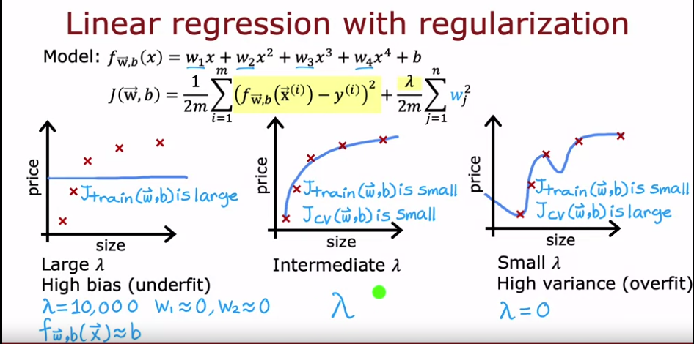

Choosing the Optimal Lambda with Cross-Validation
Recap: Setting Lambda for a Fourth-Order Polynomial with Regularization
We explored how to choose the optimal Lambda parameter for regularization, balancing bias and variance.
Procedure using Cross-Validation:
- Set up different Lambda values: Choose a range of potential values (e.g., 0.001, 0.01, 0.1, 1, 10, 100).
- Train for each Lambda: For each Lambda, train the model with regularization and record the resulting parameters (w, b).
- Evaluate on cross-validation set: Compute the cross-validation error (J_cv) for each set of parameters.
- Find the best Lambda: Choose the Lambda with the lowest J_cv. This indicates the model that balances training fit and generalization best.
- Report final performance: Evaluate the chosen model on the test set for a final estimate of generalization error (J_test).
Example:
- Iterate through Lambda values (0, 0.01, 0.02, ..., 10).
- For each Lambda, record w, b, and J_cv.
- If J_cv of W5, B5 is the lowest, choose Lambda corresponding to W5, B5.
- Report J_test of W5, B5 as the final estimated generalization error.
Key Points:
- Cross-validation helps compare different Lambda values for generalization performance.
- The chosen Lambda balances J_train and J_cv, avoiding underfitting and overfitting.
- Test set error reflects the final expected performance on unseen data.
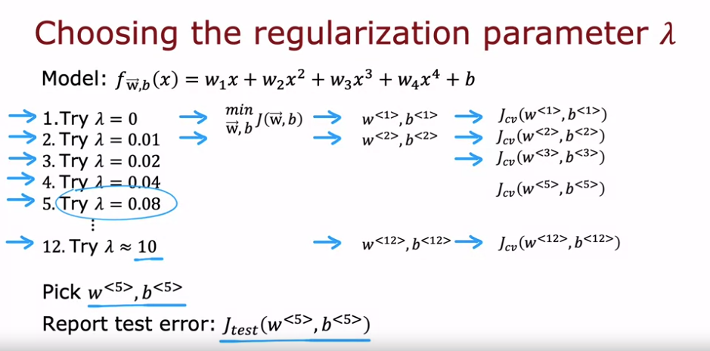

Understanding Bias, Variance, and Lambda with Visualizations
Key players:
- J_train: Training error (how well the model fits the training data)
- J_cv: Cross-validation error (how well the model generalizes to unseen data)
- Lambda: Regularization parameter (controls the trade-off between fitting the data and keeping parameters small)
Scenarios:
High variance (low Lambda):
- Model overfits the training data (J_train is low).
- Performs poorly on unseen data (J_cv is high).
- Imagine a very wiggly curve fitting training data closely but missing the bigger picture.
High bias (high Lambda):
- Model underfits the training data (J_train is high).
- Also performs poorly on unseen data (J_cv is high).
- Imagine a straight line far from the data points, not capturing the underlying trend.
Optimal Lambda:
- J_train and J_cv are both relatively low.
- The model balances fitting the data and generalizing well.
- Imagine a smoother curve that captures the essential trend without overfitting.
Finding the optimal Lambda:
- Use cross-validation: try different Lambda values and pick the one with the lowest J_cv.
- This is similar to finding the right degree of a polynomial (d) in the previous video, but with Lambda as the tuning parameter instead.
Relationship between plots:
- The plots of J_train vs. Lambda and J_cv vs. Lambda can be seen as "mirror images" of each other.
- In both cases, cross-validation helps choose the best parameter value (d or Lambda) to avoid high bias or variance.
Remember:
- Understanding these concepts is crucial for improving machine learning performance.
- Analyze J_train, J_cv, and Lambda to diagnose bias, variance, and choose the right model complexity.
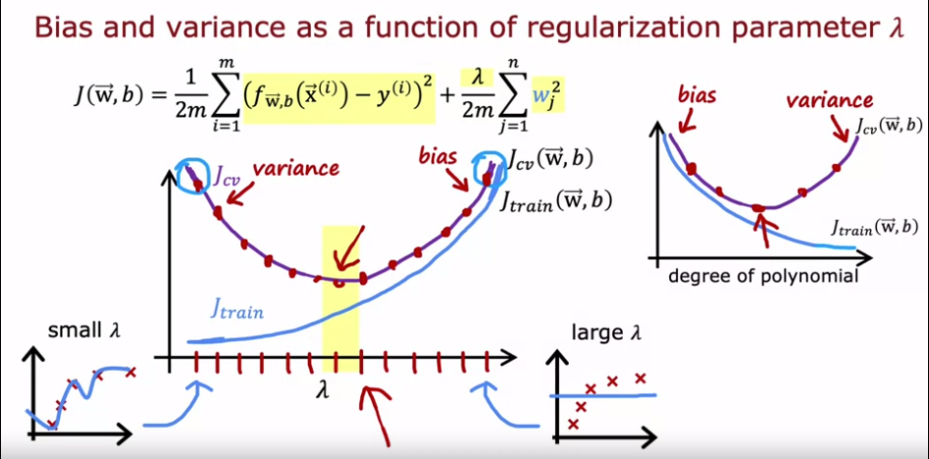

Diagnosing Bias vs. Variance in Speech Recognition: Key Points
Scenario: Speech recognition system with:
- J_train: 10.8% error (10% wrong on training data)
- J_cv: 14.8% error (higher error on cross-validation set)
Initial Analysis:
- High J_train suggests high bias (underfitting).
- J_cv gap (4%) seems small for high variance.
Considering Human Performance:
- Human error: 10.6% (representing intrinsic difficulty)
- Algorithm error is close to human performance (0.2% higher).
Revised Analysis:
- J_train relative to human error suggests low bias.
- Large J_cv gap indicates high variance (overfitting).
Conclusion:
- The algorithm has more of a variance problem than a bias problem.
Key Takeaways:
- Compare J_train to human performance for better bias assessment.
- Large J_cv gap suggests overfitting, even if J_train seems high.
- Analyze errors in context of specific application and task difficulty.
Additional Notes:
- This example highlights the importance of domain-specific considerations.
- Benchmarking against human performance provides valuable context.
- Understanding bias vs. variance helps choose appropriate regularization strategies.
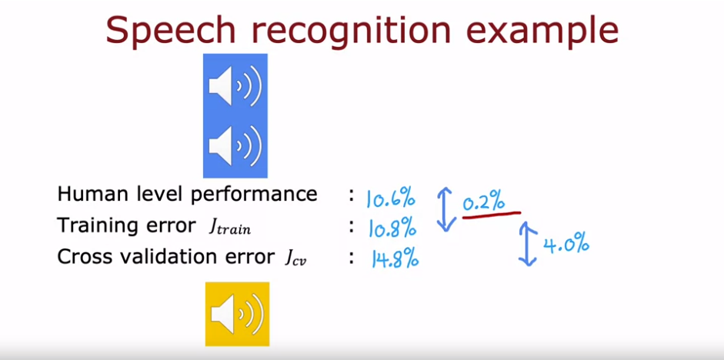

Establishing Baseline Performance for Machine Learning: Key Points
Key Takeaways:
- Baseline performance: Expected error level for a task, used to judge your algorithm's performance.
- Unstructured data: Audio, images, text - often benefit from human-based baselines.
- Human performance: A strong benchmark for judging algorithm performance on tasks humans excel at.
- Competing algorithms: Previous or competitor implementations can set baselines.
- Prior experience: Use experience to estimate achievable performance levels.
Benefits of Baselines:
- Calibrate expectations: Avoids unrealistic expectations, allowing for better resource allocation.
- Compare algorithms: Facilitates objective comparisons between different approaches.
- Track progress: Measures improvement over time and helps identify areas for further development.
Choosing the Right Baseline:
- Human performance: Strong choice for tasks naturally handled well by humans (e.g., speech recognition, image understanding).
- Competing algorithms: Relevant for established tasks, provides a clear performance goal.
- Prior experience: Useful when no other baselines are available, requires careful estimation.
Remember:
- Baselines are crucial for evaluating machine learning performance in a meaningful way.
- Choose the most appropriate baseline method based on the task and available data.
- Regularly assess and update baselines as the field progresses and new benchmarks emerge.
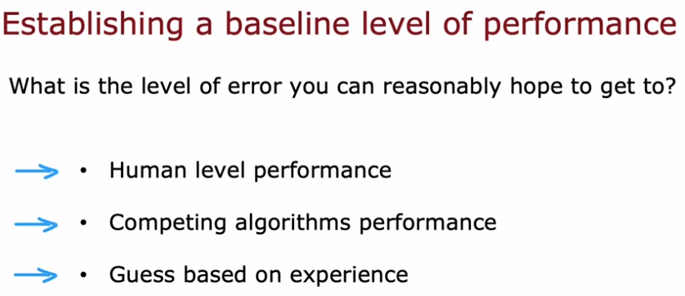
Key Points:
- Baseline performance: Crucial reference for assessing machine learning algorithm performance.
- Baseline sources: Often human performance for unstructured data, but can also be competing algorithms or prior experience.
- Diagnosing bias/variance:
  - Gap between training error and baseline: Large gap suggests high bias (underfitting).
  - Gap between training error and cross-validation error: Large gap suggests high variance (overfitting).
- Interpreting gaps: Lower gaps are favorable, indicating good fit and generalizability.
- Considerations:
  - Baseline can be 0% for perfect performance tasks.
  - Noisy data may require higher baselines.
  - Algorithms can have both high bias and high variance (less common).
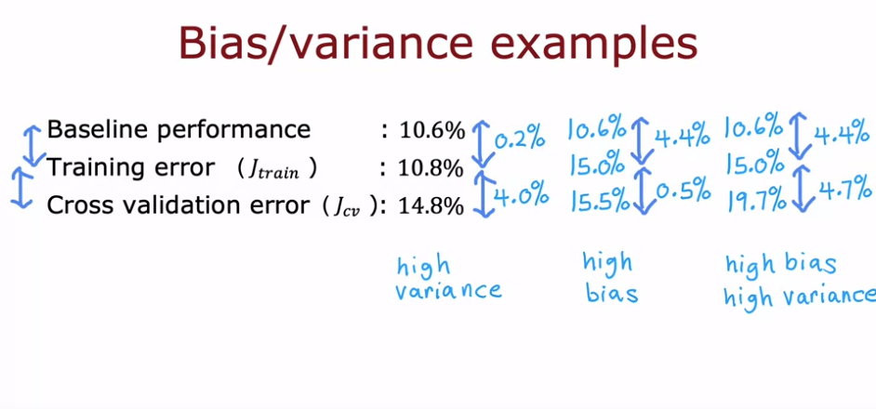

Learning Curves:
The learning curves illustrate how the performance of a learning algorithm changes with the amount of training data it receives. When plotting the cross-validation error (J_cv) against the training set size (m_train), it typically decreases as more data is provided. Conversely, the training error (J_train) may increase with the training set size, especially for complex models. This phenomenon occurs because smaller datasets allow for easier fitting of the model, resulting in lower training error. However, as the dataset grows larger, it becomes harder for the model to fit all examples perfectly, leading to an increase in training error.
Illustration: The learning curve plot depicts two curves: one for the cross-validation error and another for the training error. As the number of training examples (m_train) increases along the horizontal axis, the cross-validation error gradually decreases, indicating improved generalization. Conversely, the training error may initially decrease with a small dataset but starts to increase as the dataset grows larger, reflecting the challenges of fitting a complex model to an extensive dataset. This divergence between the cross-validation error and training error highlights the trade-off between bias and variance in machine learning models.
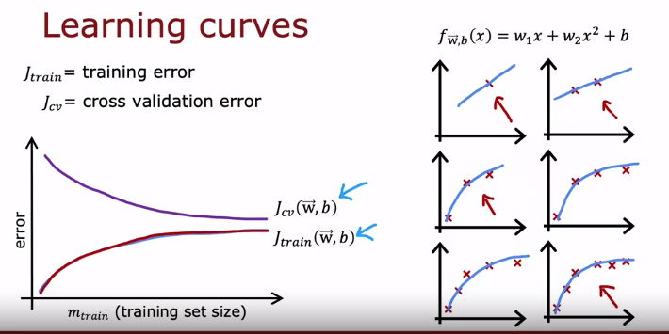

High Bias (Under fitting) in Learning Curves:
Key Points:
- Training error: Initially decreases, then plateaus (flattens out) due to limited model complexity.
- Cross-validation error: Decreases but remains higher than training error and also plateaus.
- Baseline performance: Lower than both J_train and J_cv, indicating room for improvement.
- Impact of more data: Limited improvement, curves remain flat even with infinitely large training sets.
Explanation:
- High bias occurs when the model is too simple to capture the underlying data patterns.
- Imagine fitting a straight line to non-linear data. No matter how much data you have, the straight line won't capture the complexity, leading to the plateau in curves.
- While training error improves as the model fits the data, it can't go lower due to the limited model capacity.
- Cross-validation error reflects this limitation, remaining higher than training error due to over fitting to specific training examples.
- Even with an infinite amount of data, the linear model cannot reach the baseline performance because it's fundamentally the wrong model for the data.
Example:
- Predicting house prices with a linear model based on square footage. This may underestimate expensive houses with large gardens.
- Classifying images with a simple decision tree might miss subtle features crucial for accurate prediction.
Solutions:
- Increase model complexity (e.g., use polynomial regression, decision trees with more splits).
- Use feature engineering to create new features capturing missing information.
- Consider ensemble methods combining multiple simpler models.
Remember: Throwing more data at a high-bias problem won't solve it. Choose a model that can represent the data complexity!
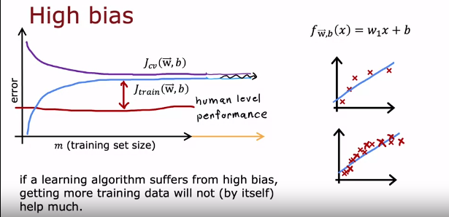

High Variance (Over fitting) in Learning Curves: Summary
Key Points:
- Training error: Increases rapidly with training set size as the model memorizes specific examples.
- Cross-validation error: Much higher than training error, indicating poor generalization.
- Baseline performance: Lower than both J_train and J_cv, hinting at potential for improvement.
- Impact of more data: Often beneficial, potentially driving down cross-validation error.
Explanation:
- High variance occurs when the model is too flexible and memorizes training data noise instead of learning underlying patterns.
- Imagine fitting a high-order polynomial to data. It can perfectly fit even random noise, leading to a rapidly increasing training error.
- This over fitting to noise causes poor performance on unseen data, reflected in the high cross-validation error.
- The gap between J_train and J_cv highlights the over fitting issue.
Example:
- Predicting customer churn with a complex decision tree might over fit individual customer preferences, leading to poor generalization.
- Classifying images with neural networks with many layers and neurons can get lost in irrelevant details, hindering generalization.
Solutions:
- Reduce model complexity (e.g., use lower-order polynomials, simpler decision trees).
- Apply regularization techniques to penalize complex models and encourage generalization.
- Use early stopping to halt training before over fitting occurs.
Remember: More data can help with high variance, but only if it's diverse and representative of the real world. Choose a model and training approach that prioritize generalizability!
Additional Notes:
- Plotting learning curves with different training set sizes can be computationally expensive.
- It's a valuable mental model to understand high bias vs. high variance behavior.
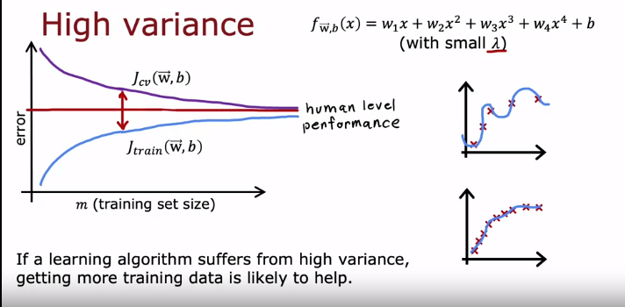
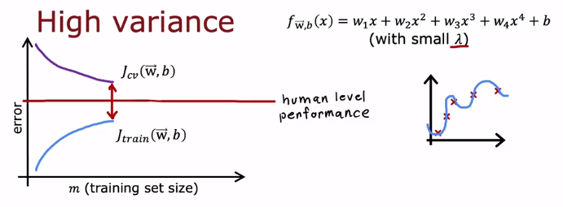

Deciding what to try next revisited
Key Takeaways:
- Analyze training error (J_train) and cross-validation error (J_cv) to identify bias or variance issues.
- High bias: J_train is low but J_cv is high, indicating underfitting.
- High variance: J_train is high and J_cv is even higher, indicating overfitting.
Fixing Strategies:
High Bias:
- Increase model complexity:
  - Use more features (e.g., number of bedrooms in house price prediction).
  - Add polynomial features (e.g., account for non-linear relationships).
  - Decrease regularization (Lambda) to allow more flexibility.
- Get more training data: Not always helpful, but may provide necessary information for complex models.
High Variance:
- Simplify model:
  - Use fewer features (remove irrelevant or redundant ones).
  - Increase regularization (Lambda) to penalize complex models.
- Get more training data: Often beneficial, providing diverse examples to avoid overfitting.
Remember: Don't reduce training set size for high bias; it worsens performance.
Examples:
- High bias in predicting house price based only on size: Add features like bedrooms, floors, age to capture more relevant information.
- High variance in classifying images with a complex neural network: Reduce network size or layers, or increase regularization to avoid overfitting to noise.

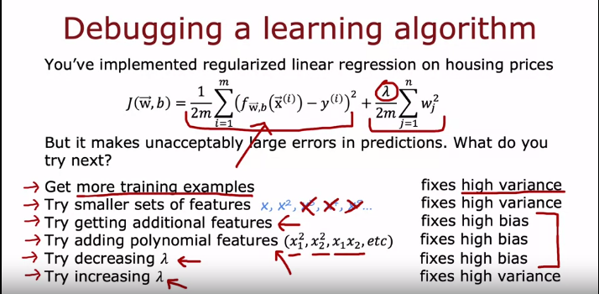

Neural Networks and Overcoming Bias-Variance Tradeoff
- High bias and high variance are both detrimental to the performance of machine learning algorithms.
- High bias occurs when the model is too simplistic and fails to capture the underlying patterns in the data, leading to underfitting.
- High variance occurs when the model is overly complex and captures noise in the data, leading to overfitting.
- The bias-variance tradeoff refers to the delicate balance between bias and variance in model selection.
- In the context of polynomial regression, choosing a low-degree polynomial results in high bias, while choosing a high-degree polynomial results in high variance.
- Machine learning engineers must find the optimal tradeoff between bias and variance by adjusting the model complexity or regularization parameters.
- Neural networks offer a solution to the bias-variance tradeoff by automatically learning complex patterns from large datasets, potentially mitigating both high bias and high variance.
- However, neural networks may still suffer from overfitting if not properly regularized or if the dataset is too small.
- Overall, neural networks provide a powerful tool to address the bias-variance tradeoff, but careful model selection and regularization are still crucial for optimal performance.
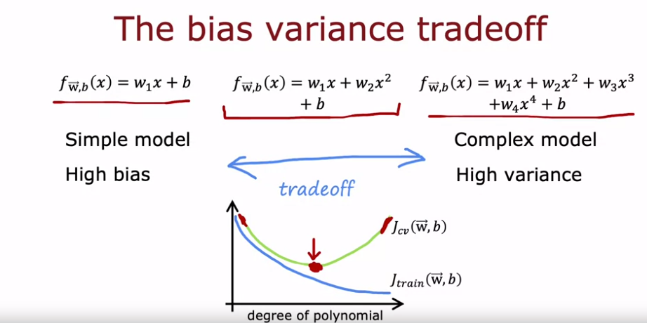

Recipe for Reducing Bias and Variance in Neural Networks:

- Introduction to Bias and Variance:
  - High bias occurs when the model is too simplistic and underfits the data.
  - High variance occurs when the model is too complex and overfits the data.
  - Balancing bias and variance is crucial for optimal model performance.
- Recipe for Reducing Bias:
  - Train the algorithm on the training set and measure training error (Jtrain).
  - If Jtrain is high, indicating high bias, increase the model complexity.
  - Increase model complexity by adding more hidden layers or units per layer.
  - Iterate this process until the model performs well on the training set.
- Addressing Variance Issues:
  - Once the model performs well on the training set, evaluate its performance on the cross-validation set.
  - If there's a large gap between training and cross-validation error (Jcv), indicating high variance, consider collecting more data.
  - Iterate the process of training, evaluating, and potentially collecting more data until the model performs well on both training and cross-validation sets.
- Limitations and Considerations:
  - Increasing model complexity may not always reduce bias and can become computationally expensive.
  - Availability of large datasets and computational resources can influence the effectiveness of this approach.
  - The recipe highlights the importance of iteratively addressing bias and variance during the development of a learning algorithm.
  - This approach is not always applicable but it can be very powerful when it fits.
- Rise of Deep Learning:
  - Advances in hardware, such as GPUs, have facilitated the training of large neural networks.
  - Access to vast amounts of data has further enabled the success of deep learning in various applications.
  - The ability to train large neural networks has contributed to significant performance improvements across different domains.

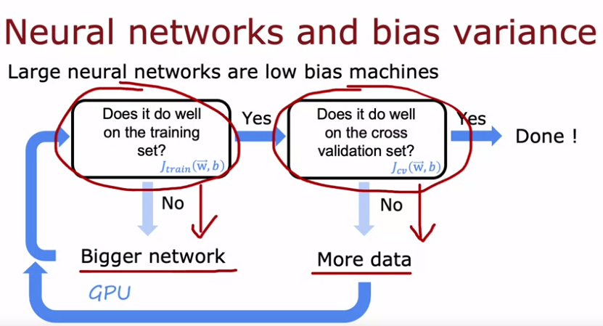

Larger Neural Networks with Regularization: Summary
Key Point: Larger neural networks with appropriate regularization are unlikely to increase variance and often perform better than smaller models.
Explanation:
- Intuitively, larger networks seem prone to overfitting (high variance).
- However, with proper regularization, they can effectively avoid this pitfall.
- Regularization techniques like weight decay or dropout penalize complex models, encouraging simpler, generalizable patterns.
Benefits:
- Larger models can represent more complex relationships in data, potentially reducing bias.
- With regularization, they retain the ability to generalize well to unseen examples.
Tradeoff:
- Increased computational cost: training and inference become slower with larger models.
Takeaway:
- Consider using larger neural networks with well-chosen regularization for better performance, especially when data allows.
- Be mindful of the computational cost associated with training and using larger models.
Additional Notes:
- Choosing the right regularization technique and parameters is crucial for optimal performance.
- This principle doesn't hold true for infinitely large networks, but practical limitations come into play before reaching that point.
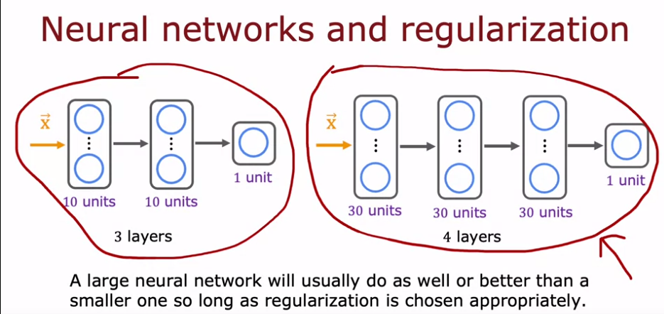

Regularization in Neural Networks with TensorFlow:
Key Points:
- Larger neural networks with L2 regularization (weight decay) are generally preferred.
- Regularization penalizes complex models, encouraging simpler and more generalizable patterns.
- TensorFlow allows easy implementation of L2 regularization through tf.keras.regularizers.l2.
- Set desired weight decay value (lambda) and optionally individual layer coefficients.
Explanation:
- Regularization in Neural Networks aims to prevent overfitting and improve generalization.
- L2 regularization adds a penalty term based on the sum of squared weights to the loss function.
- TensorFlow's tf.keras.regularizers.l2 function simplifies adding regularization during model creation.
- You can specify a global or individual layer-wise regularization coefficient (lambda).

from sklearn.datasets import load_iris
from sklearn.model_selection import train_test_split
from sklearn.preprocessing import StandardScaler
import numpy as np
from tensorflow import keras
from tensorflow.keras import layers
from tensorflow.keras.regularizers import l2
# Load the dataset
iris = load_iris()
X = iris.data
y = iris.target
# Split the data into training and testing sets
X_train, X_test, y_train, y_test = train_test_split(X, y, test_size=0.2, random_state=42)
# Standardize the features
scaler = StandardScaler()
X_train_scaled = scaler.fit_transform(X_train)
X_test_scaled = scaler.transform(X_test)
# Define network architecture
model = keras.Sequential([
layers.Dense(128, activation="relu", kernel_regularizer=l2(0.01)), # Regularize 1st layer
layers.Dense(64, activation="relu", kernel_regularizer=l2(0.005)), # Regularize 2nd layer
layers.Dense(10, activation="softmax") # No regularization on output layer
])
# Compile the model
model.compile(optimizer='adam',
loss='sparse_categorical_crossentropy',
metrics=['accuracy'])
# Train the model
model.fit(X_train_scaled, y_train, epochs=10, validation_data=(X_test_scaled, y_test))

Remember:
- Choose an appropriate lambda value based on your dataset and problem.
- Consider other regularization techniques (e.g., dropout) for specific scenarios.
- Regularization often improves performance but slightly increases training time.
